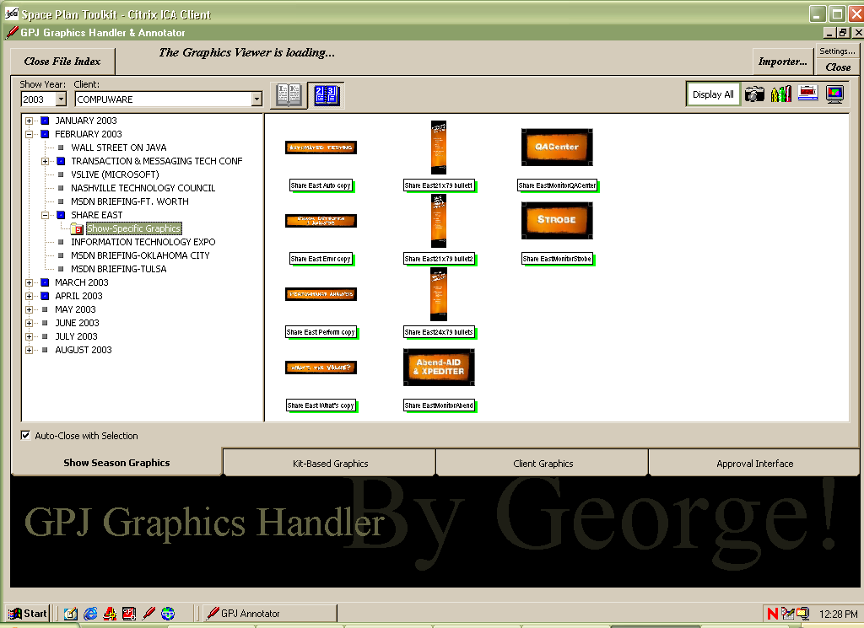
SHOW SEASON GRAPHICS Tab - Chronological View

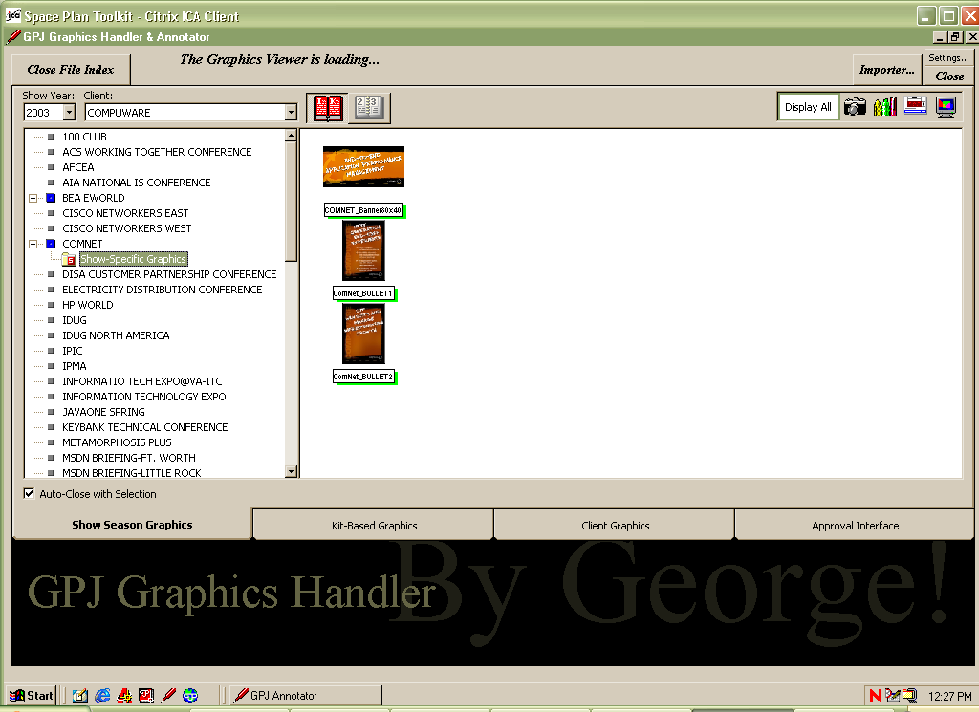
SHOW SEASON GRAPHICS Tab - Alphabetical View
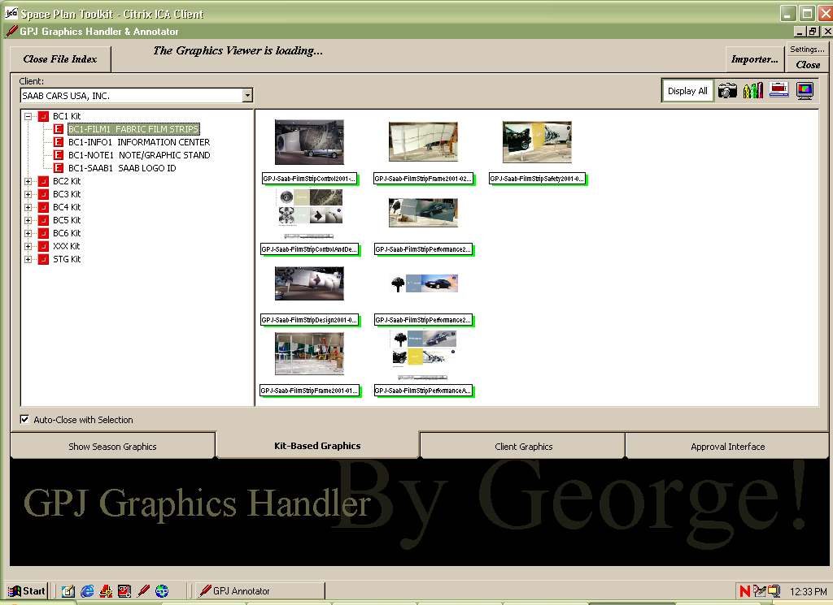
KIT-BASED GRAPHICS Tab

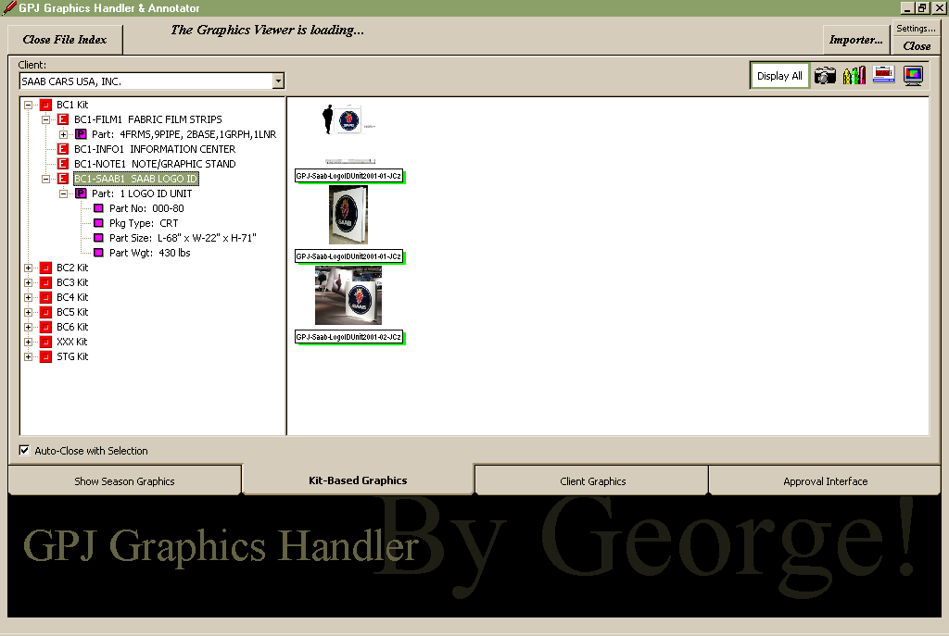
KIT-BASED GRAPHICS Tab – w/Exposed Part Data

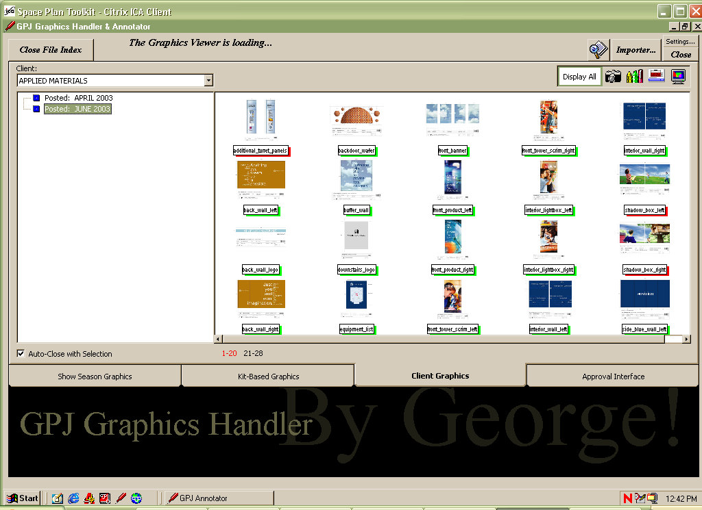
CLIENT GRAPHICS Tab

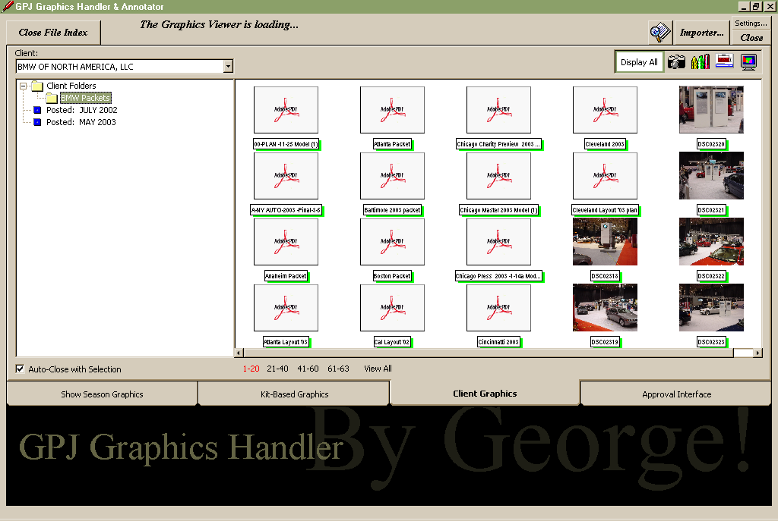
CLIENT GRAPHICS Tab - w/Custom Folder option

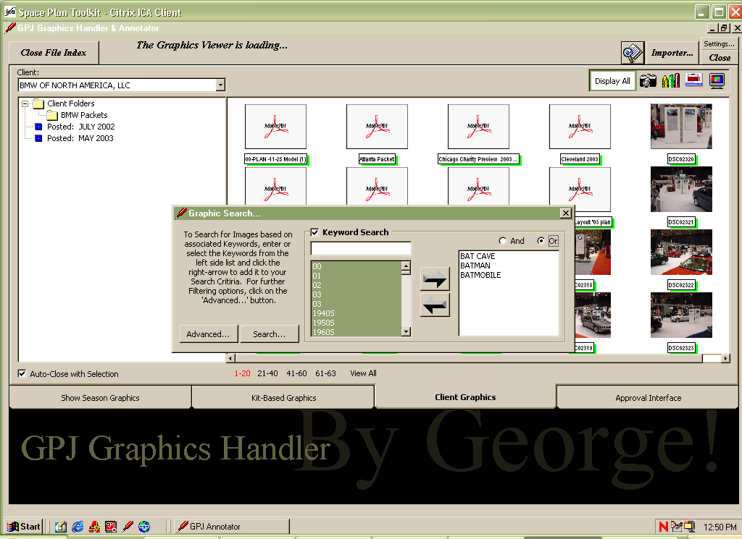
CLIENT GRAPHICS Tab – Simple Keyword Search

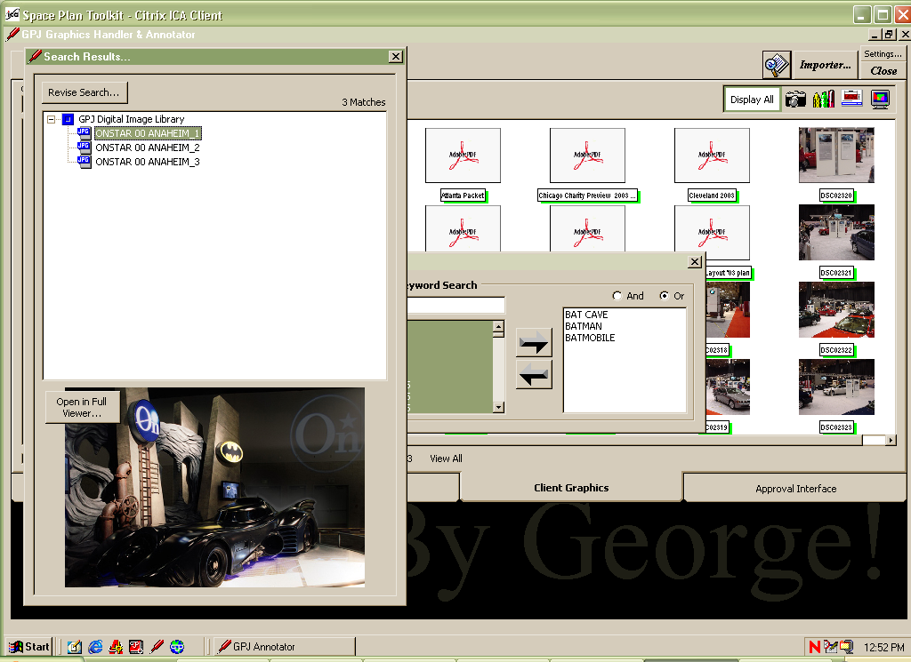
CLIENT GRAPHICS Tab – Simple Keyword Search Result

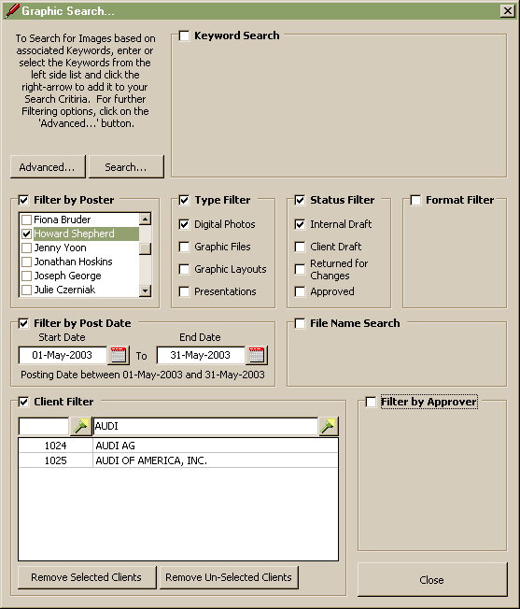
CLIENT GRAPHICS Tab – Advanced Search Option

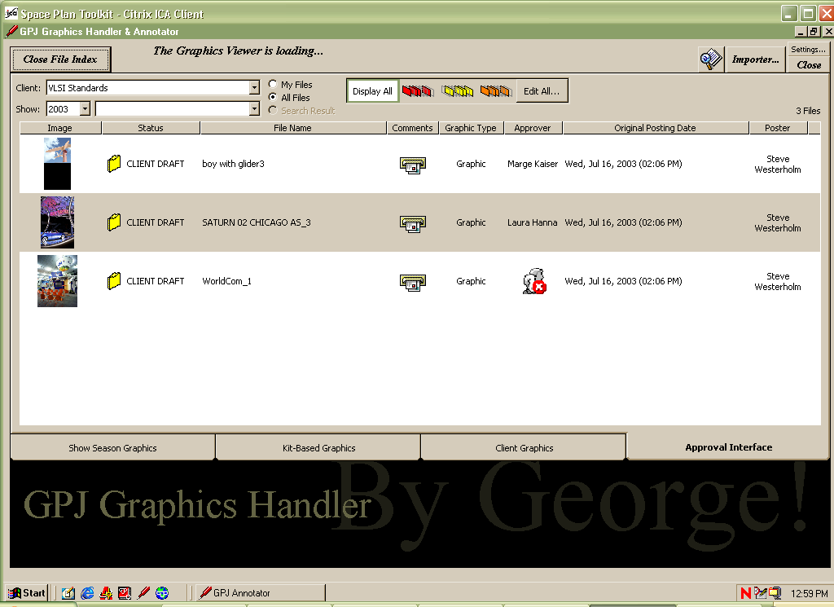
APPROVAL INTERFACE Tab

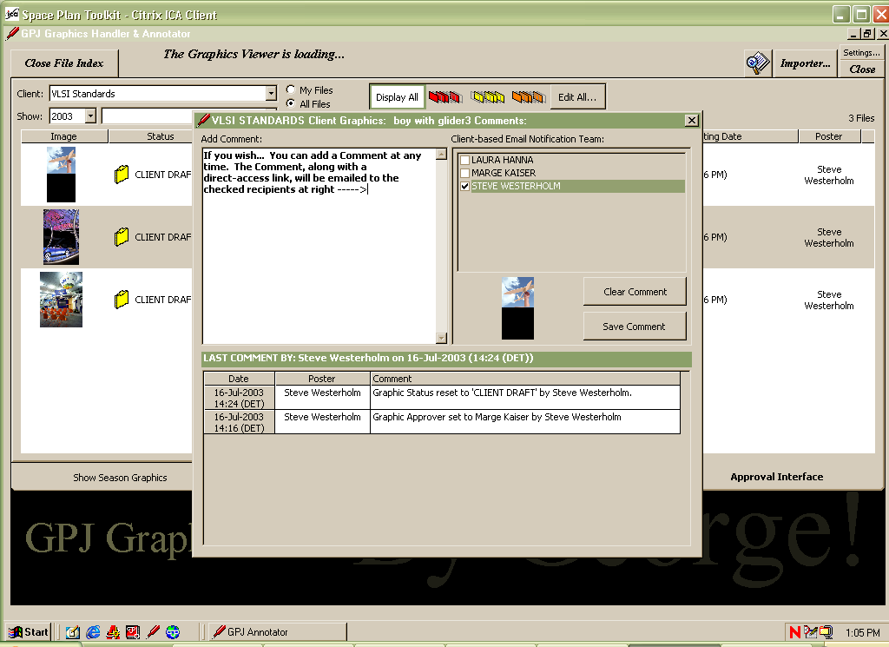
COMMENTS INTERFACE – Available from all tabs

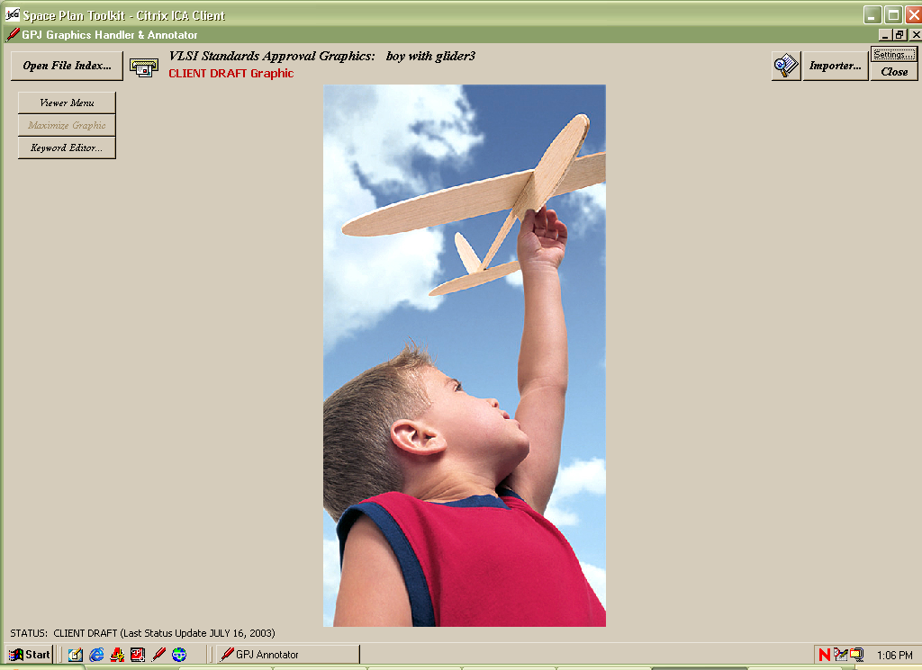
FULL VIEWER MODE – Available from all tabs by clicking thumbnail

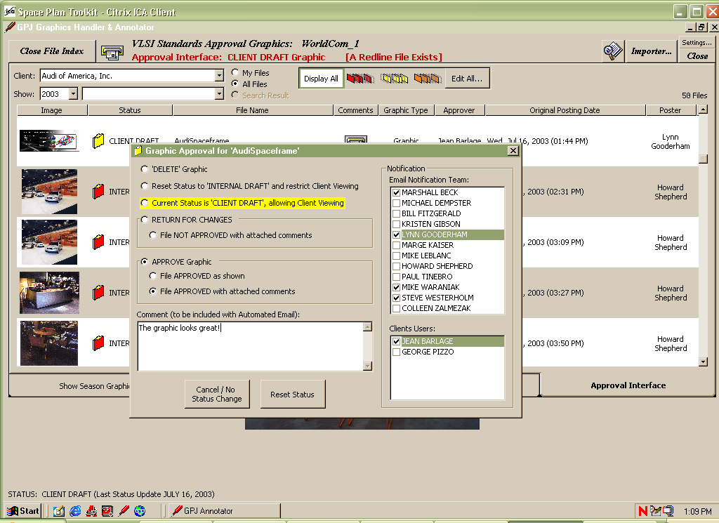
APPROVAL INTERFACE Tab – Graphic Approval Menu

